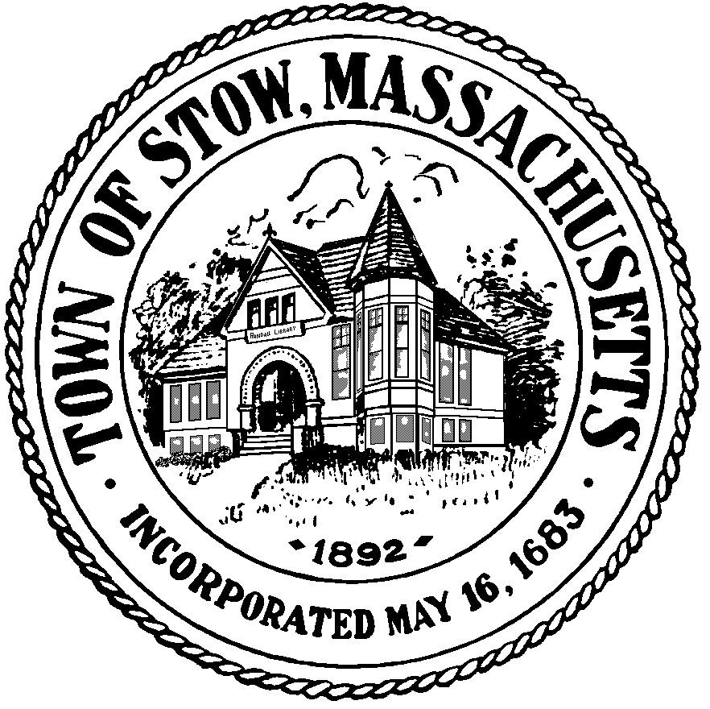

Town of Stow

community preservation committee

Agenda for March 10, 2014 7:30pm, Town Building
Bills & Minutes
CPA Project Proposals/ Warrant articles for Annual Town Meeting
Recreation Commission Proposal, Randall Library Proposal, annual reserves, annual administrative expenses, updating reserve amounts
Meeting Schedule
News & Views

(posted 2/24/14)

